# Evaluating Aliexpress Website According To Norman 7 Principles

**Examined Website: AliExpress**

**Website Link:** [**https://www.aliexpress.us/?gatewayAdapt=glo2usa**](https://www.aliexpress.us/?gatewayAdapt=glo2usa)

**Study:** Evaluating the sample website according to Norman 7 principles

**Students:**

**Hatice Çankaya**

**Baki Akgün**

**Neslihan Çatak**

1.ABSTRACT

2. INTRODUCTION

3. LITERATURE REVIEW

4. FINDINGS AND RESULTS

5. DISCUSSION

6. CONCLUSION

7.REFERENCES

8. ACKNOWLEDGMENTS

ABSTRACT

The purpose of this report is to compare Norman's 7 principles on Aliexpress, the website we have identified, and to examine the site's compliance with the principles. We have divided our report into 8 parts, most of which are related to principles. On the other hand, this study, which was conducted to analyze how user friendly the user interface design of the Aliexpress site is, aims to identify the strengths and areas for improvement. Donald Norman is a renowned expert in HCI and UX and in his book "The Design of Everyday Things" he sets out 7 user-friendly principles. We also evaluated the site we mentioned by adopting this principle.

Introduction

The importance of User Expreiance (UX) is increasing due to the increase of systems and users.In this study, we have examined the sites and principles we have mentioned as a team. In the Literature Review section, we have reviewed and cited previous studies and research. In the Finding and Results section, we evaluated the Aliexpress site with examples according to 7 principles.In the Discussion section, we discussed the strengths and areas for improvement of the Aliexpress website. In the Conclusion section, we have the general results of the study and our comments on the applicability of the principles on the site. The References section includes links to the sources we used to prepare this report, while the Acknowledgments section includes the names of those who contributed. We now begin our study with the Literature Review section.

Literature Review

In the study of human-computer interaction (HCI), Don Norman's 7 design principles are essential for evaluating and improving user interfaces. These principles include discoverability, feedback, conceptual model, consistency, constraints, error prevention, and flexibility. This review looks at how these principles apply to the AliExpress website, using relevant HCI literature to understand the findings.

Norman's book, "The Design of Everyday Things" (2013), is a key reference for these principles. Norman explains that good design should help users find what they can do, get clear feedback, and understand how the system works. His principles are used widely in many HCI studies, showing their importance and usefulness in different contexts.

Other researchers like Nielsen (1995) and Shneiderman (1998) build on Norman’s ideas, especially for web usability. Nielsen's usability heuristics and Shneiderman's design principles emphasize the need for consistency, preventing errors, and providing helpful constraints. Their work shows that interfaces should not only work well but also make users happy and efficient.

When evaluating AliExpress, this study uses these well-known frameworks to check the site based on Norman's principles. Research on e-commerce usability, like the work by Chen and Macredie (2005), gives more insights into the challenges and best practices for online shopping sites. These studies point out common problems like too much information, inconsistent design, and language issues, all of which can affect user experience.

Applying Norman's principles to AliExpress helps this study understand the site's strengths and weaknesses. For example, the principle of discoverability is looked at using research by Marchionini (2006), who studies how users navigate complex information. The feedback on AliExpress is examined through the work of Card, Moran, and Newell (1983), who talk about the importance of quick and clear feedback in interactive systems.

In short, this literature review combines important theories and modern studies in HCI to create a framework for analyzing the AliExpress website. Using Norman's 7 design principles, supported by key HCI literature, helps provide a detailed look at the site's user experience, pointing out areas for improvement and best practices in e-commerce design.

Finding and Results

1. **Visibility:** Ensuring users can easily understand the functions and status of the system. It allows users to see clearly what is happening and what actions they can take.
2. **Feedback:** Provides users with confirmation that their actions have been received and understood by the system. By responding to user actions, it clearly shows the results of the user’s behavior.
3. **Constraints:** Refers to limitations that prevent users from making errors or minimize the harmful consequences of those errors.
4. **Tolerance:** A design that can tolerate or correct user mistakes improves the user experience.
5. **Consistency:** Ensures that similar functions operate in similar ways to avoid unexpected situations when users navigate the system.
6. **Affordance:** Design elements that provide natural cues about how to use objects or controls, helping users quickly understand how to interact with them.
7. **Mapping:** Specifies the relationship between user actions and their results, helping users accurately predict the outcomes of their actions.

**1. visibility (Discoverability)**

**Discoverability** refers to the ease with which a user can see the lifecycle and options of a system and its parts. This principle makes the user experience better by allowing users to find what they need quickly and easily. Let's take a look at how this principle is implemented on Aliexpress.

**Navigation Menu:**

Navigation Menu: Aliexpress' homepage features a black navbar with buttons like "Search", "Sign in, "Categories" and a shopping cart icon. This intuitive and accessible design gives users a clear path to the features they need.

The "All Categories" section is also designed in such a way that users can access it directly from the navigation bar. The search bar has also been used in line with these principles. Furthermore, the search bar stands out with a design that draws the user's attention by using white on a black theme.

 

**Information Hierarchy:**

Information hierarchy is well implemented in the navigation bar, homepage and other tabs we looked at, using larger and bold text for emphasis. Another feature is the choice of colors, as seen in the example below or in other cases. Colors have subconscious meanings. For example, in the red-themed design below, red is used to attract attention. Because red is a color that attracts attention in psychology.



Another example that fits the principle of visibility is simplicity and high resolution photos. High quality photos are important elements that attract the user's first attention and contribute to accessibility. Simplicity also supports this.

**2.Feedback Principle**

The Feedback Policy ensures that users receive information and guidance as a result of their actions and choices within the system. The elements used in the feedback policy should meet the following criteria:

- Immediate Feedback should respond to users' actions immediately and without delay.

- Clear: It should be clear and understandable so that users understand what the elements are and why.

- Appropriate: It should be appropriate to the user's action and the state of the system. - Consistent: Dominant and consistently presented across the system.

- Helpful: Help users understand what to do next or how to solve a problem. Immediate

Response: Users expect a response with every button click or interaction. For example, the hover growth of buttons on the homepage provides a good user experience.

.

In addition, clicking on a button often opens the relevant page in a new tab. This aspect could be improved. Similarly, the movable category section at the bottom stops abruptly on hover.

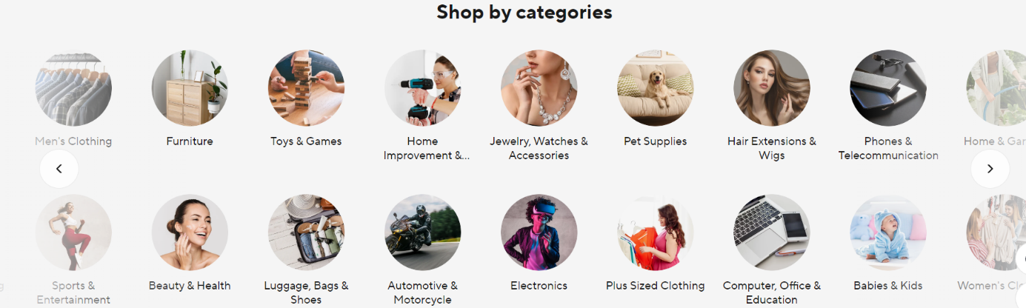

Getting the right feedback is another important factor. Providing instant feedback to immediately alert the user to incorrect input is also in line with this principle. For example, when a user creates an account, it immediately shows a red warning at the bottom and suggests the correct letters at the bottom. This is another example of the principle in action.  
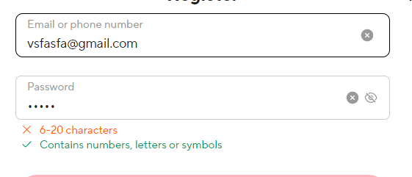

However, the site seems to need improvement in providing continuous and instant feedback, as the lack of instant feedback is often seen in many places. Also, there is no progress bar or similar mechanism to provide real-time updates to the user during the purchase process. In this sense, the site partially complies with the Feedback Principle and needs further development to comply with this principle.

**3.Constraints**

The principle of constraints involves using various restrictions to prevent user errors and ensure a safer shopping experience.

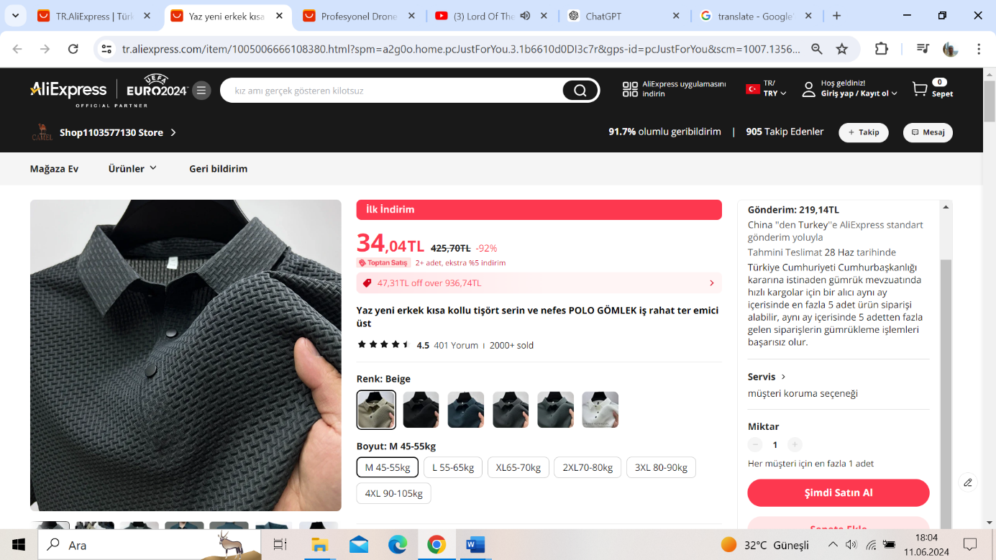Product pages do not display stock status. For clothing and accessories, dropdown menus and visual cues help users select the correct size and color.

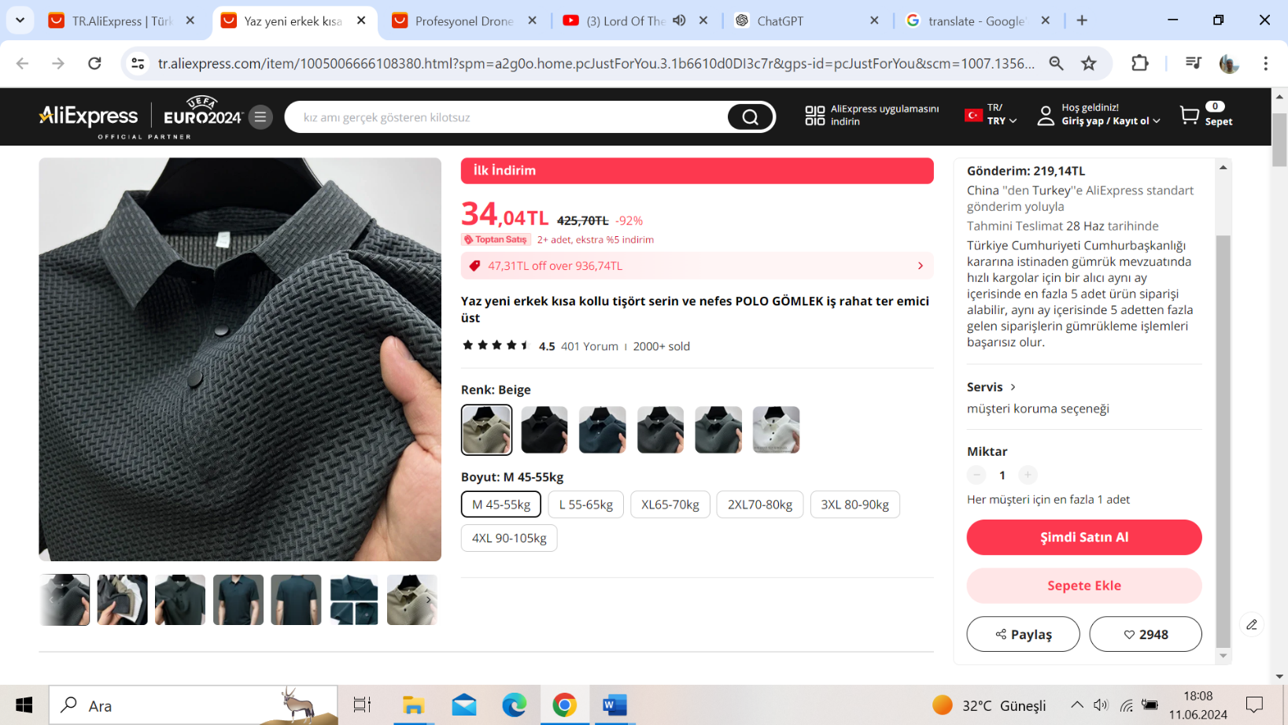Certain products have a maximum purchase limit per order. This aids stock management and prevents bulk purchasing.

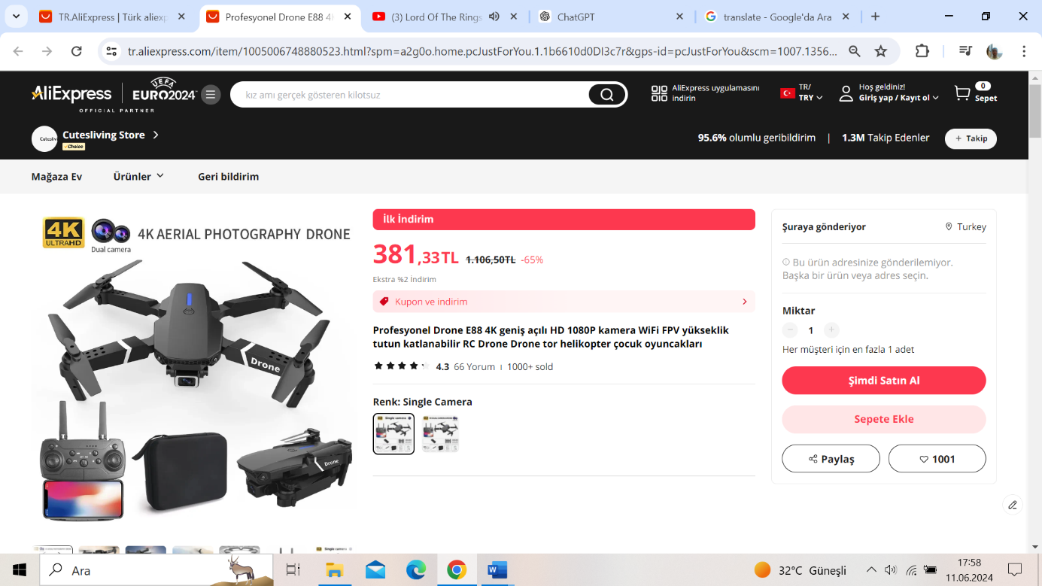It does not allow the purchase of the product for regions where delivery is not available.

Users must fill in mandatory fields like name, address, and phone number during checkout. Progress is blocked without these details. Only valid payment methods can be selected. Errors or incomplete payment details prompt error messages for corrections. High-value payments undergo additional security checks, such as verifying the match between credit card details and billing address.

Users receive immediate feedback on incorrect or incomplete information. For example, an alert appears if a credit card number is incomplete.

Forms provide instant feedback for missing or incorrect information. For instance, an incorrect email format prompts a message guiding users to the correct format.

**4.Tolerance**

The principle of tolerance improves user experience by allowing for user errors and providing means for correction.

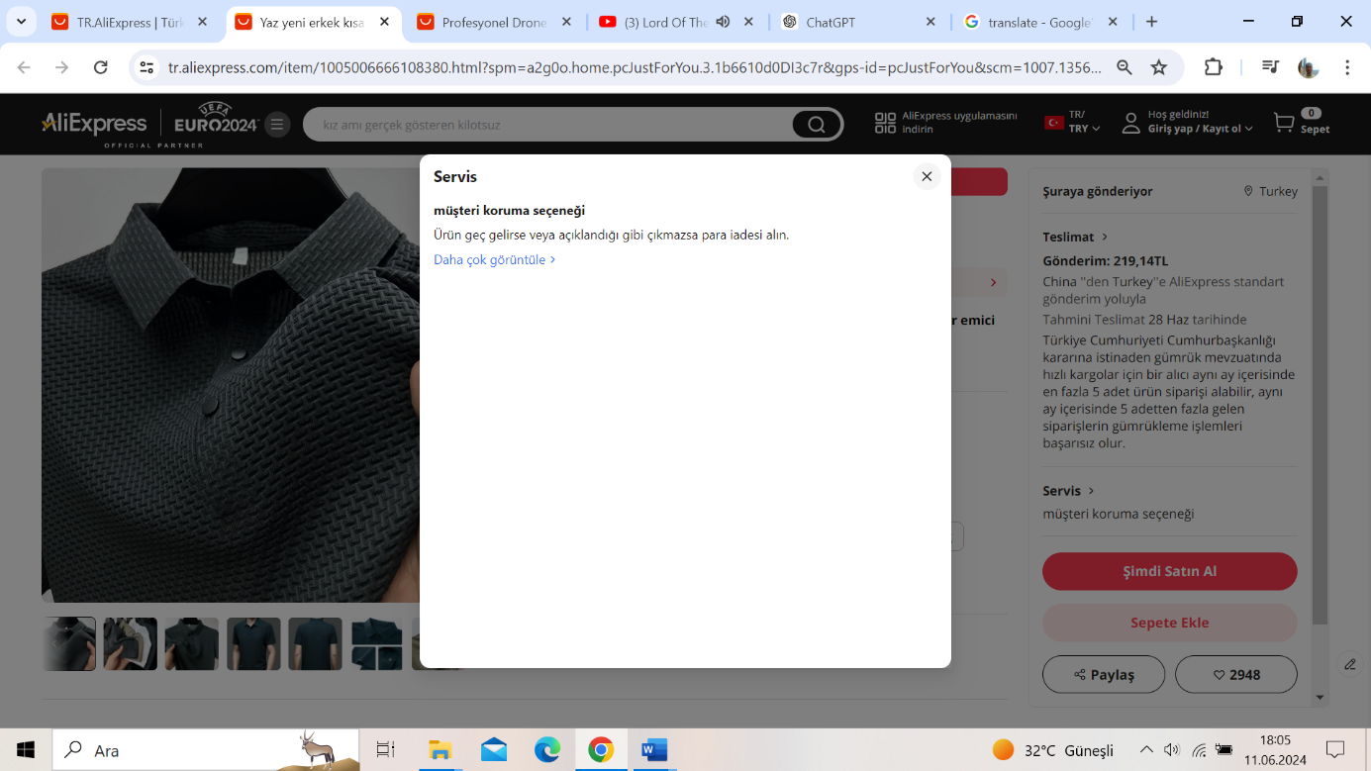Users can cancel or modify orders within a certain timeframe, allowing correction of mistakes. Users can edit address information during or after the ordering process, facilitating corrections for incorrect addresses. Users can return or exchange items within a specified period if they are unsatisfied, with detailed instructions provided.

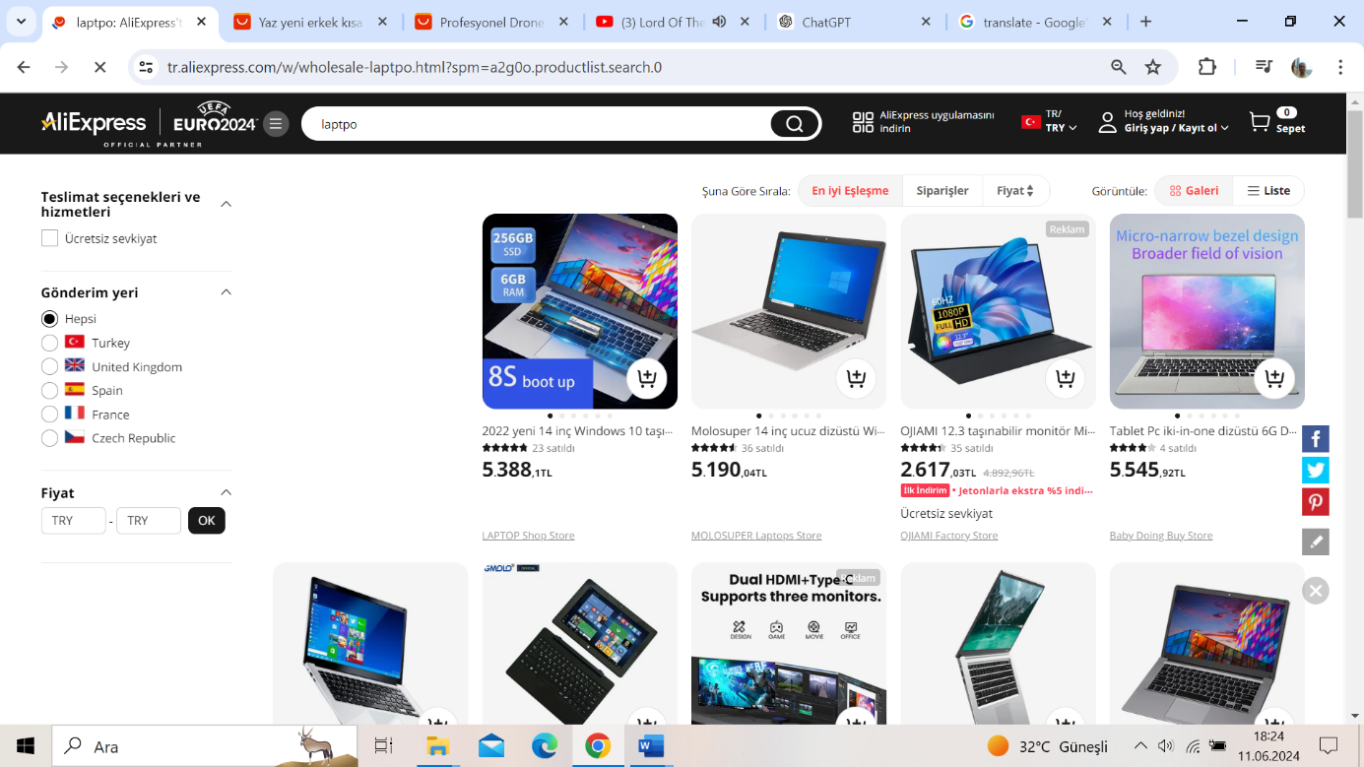Auto-completion features speed up and ensure accurate address entry. The search bar should correct spelling errors based on the principle of tolerance. However, it does not make corrections. It correctly interprets some misspelled words while failing to interpret others accurately.

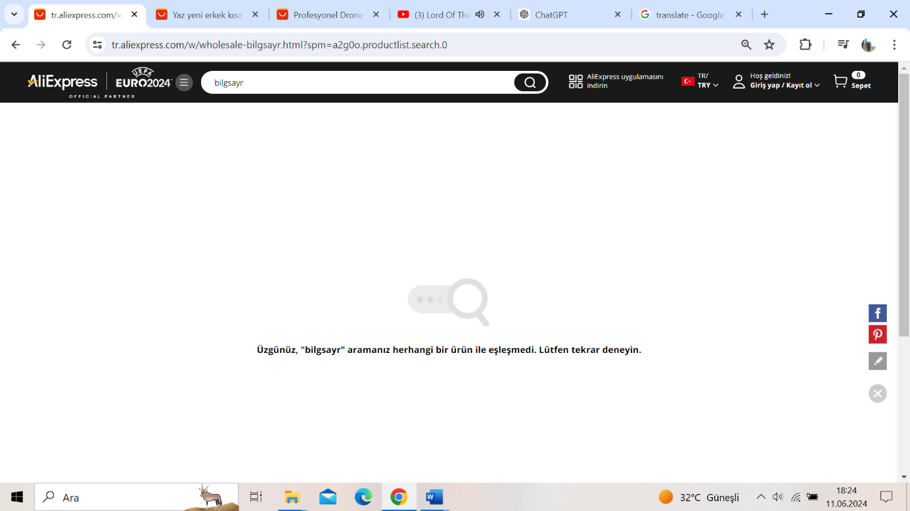

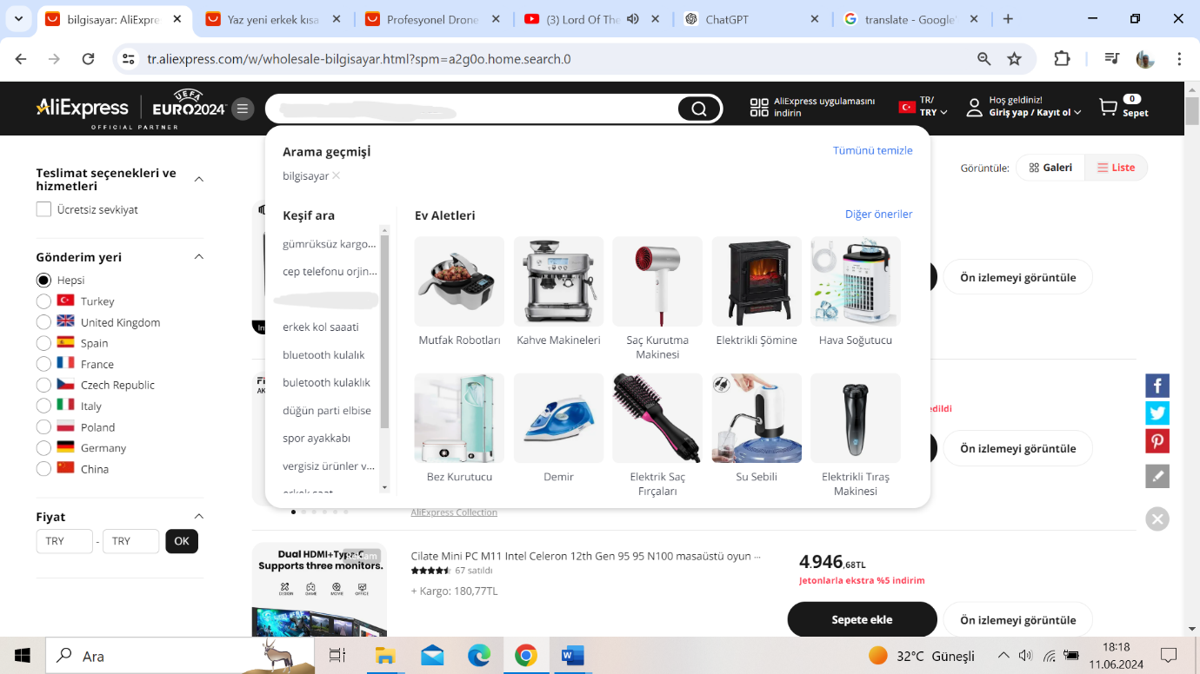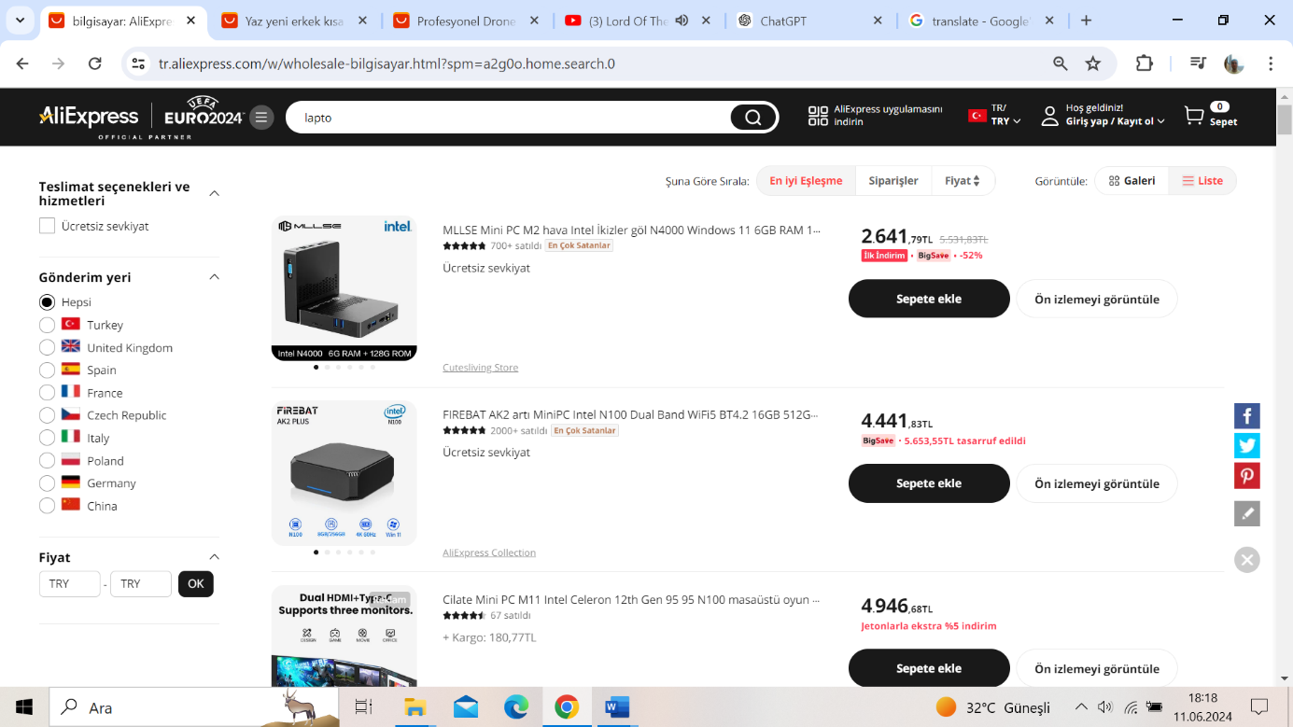Popular search terms or suggestions do not appear during search input. It also does not correct incomplete or misspelled words. When the search button is clicked, a single suggestion appears, which is not related to what the user is searching for.

Security is enhanced through two-factor authentication (e.g., SMS verification) for payments and account changes, preventing errors. A summary screen allows users to review and confirm all details before completing an order. Detailed error messages during payment indicate where the issue occurred and guide users in making corrections.

**5.Consistency**

The principle of consistency ensures a uniform experience across the interface, navigation, and functionality.

**Interface Design:**

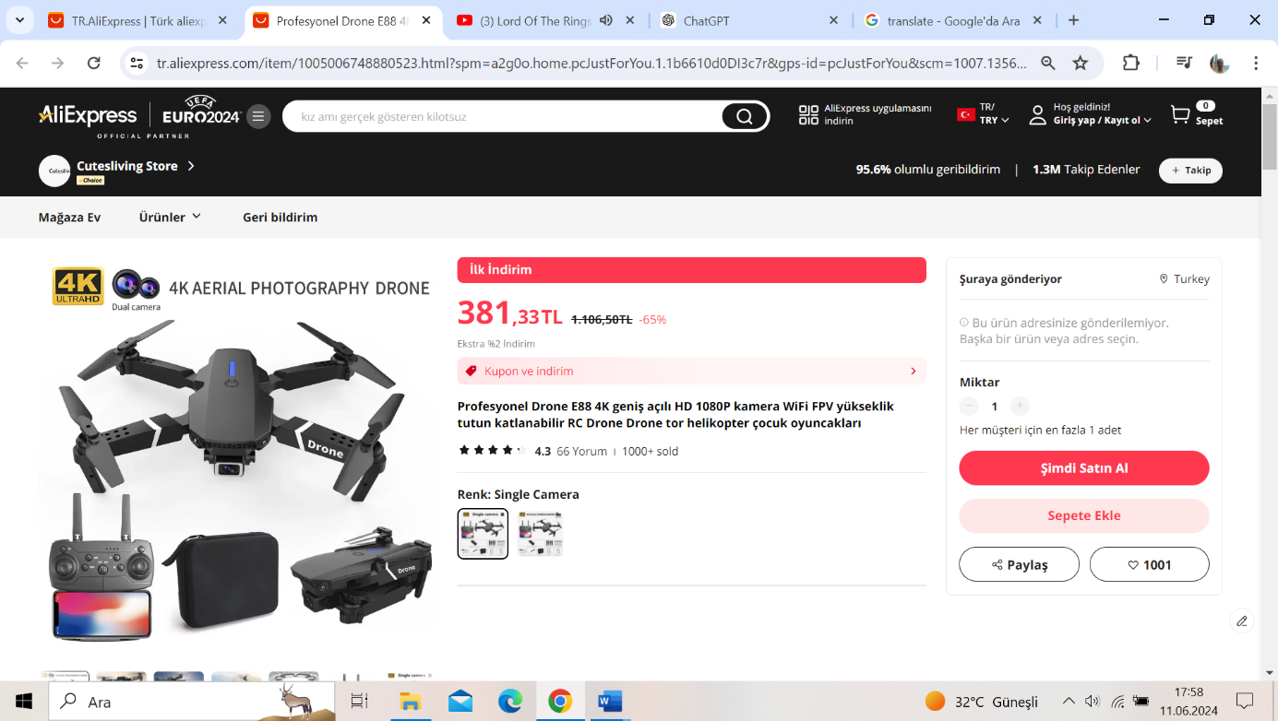



Similar color schemes and style elements are used on every page. For instance, "Add to Cart" and "Buy Now" buttons are consistently colored and positioned. Icons for functions like cart, account, and search are used consistently, making it easy for users to find what they need. Text sizes, fonts, and page layouts are used uniformly, ensuring a consistent user experience across pages.

The main and sub-menus are structured identically on all pages, facilitating easy site navigation. Product categories and filtering options are consistently arranged, making product searches straightforward.

Buttons, forms, and interactive elements provide similar types of feedback (e.g., click animations), helping users predict system behavior.

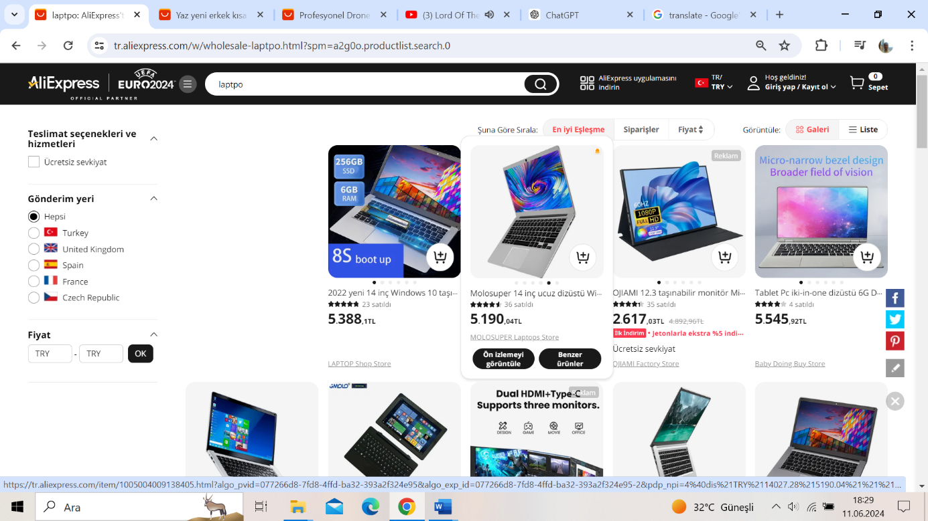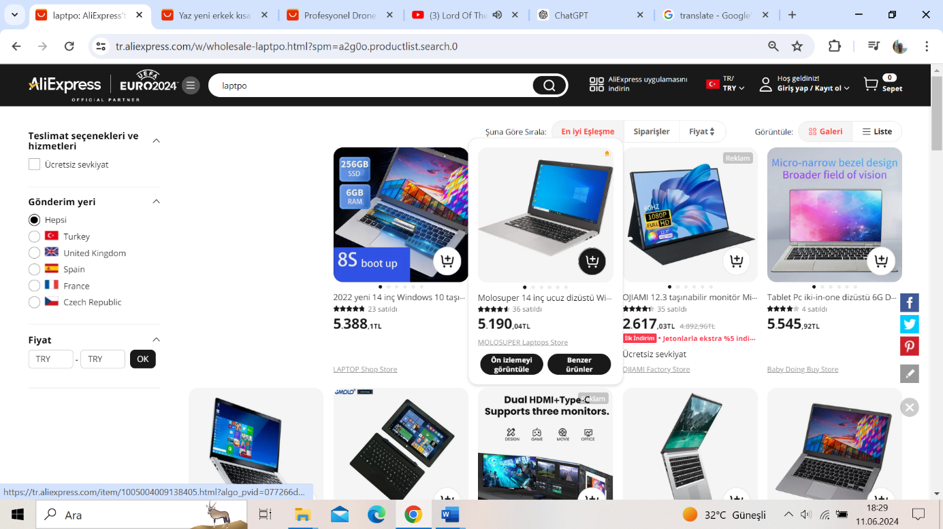

The ordering process always follows the same steps: product selection, adding to cart, entering payment details, reviewing the order summary, and completing the payment. Language and terms are consistently used throughout the site. For example, "Add to Cart" is used uniformly, preventing confusion.

**6. Affordance**

Affordance refers to an object having properties that give clues about what it can be used for and how it can be interacted with. Affordance presents this with the help of visual or perceptual cues. The aim of the Affordance principle is to enable users to interact with elements within a website or application in an intuitive and easy way, without complexity. Let's take a look at how this principle is applied on Aliexpress.

* **Use in Button Element**

6.1 example

In 6.1 example, an icon is used as a visual cue when applying the affordance principle. This way, the user intuitively understands that this button will be in the "add items to cart" function.



6.2.1 example 6.2.2 example

In 6.2.1 example, the social media logos are used as visual cues when applying the affordance principle. In this way, the user intuitively understands that the function of these buttons is "continue with the your account of the logo used".

In 6.2.2 example, “Register” and “Sign in” labels are used as perceptual cues when applying the affordance principle. In this way, the user intuitively understands that the function of these buttons.

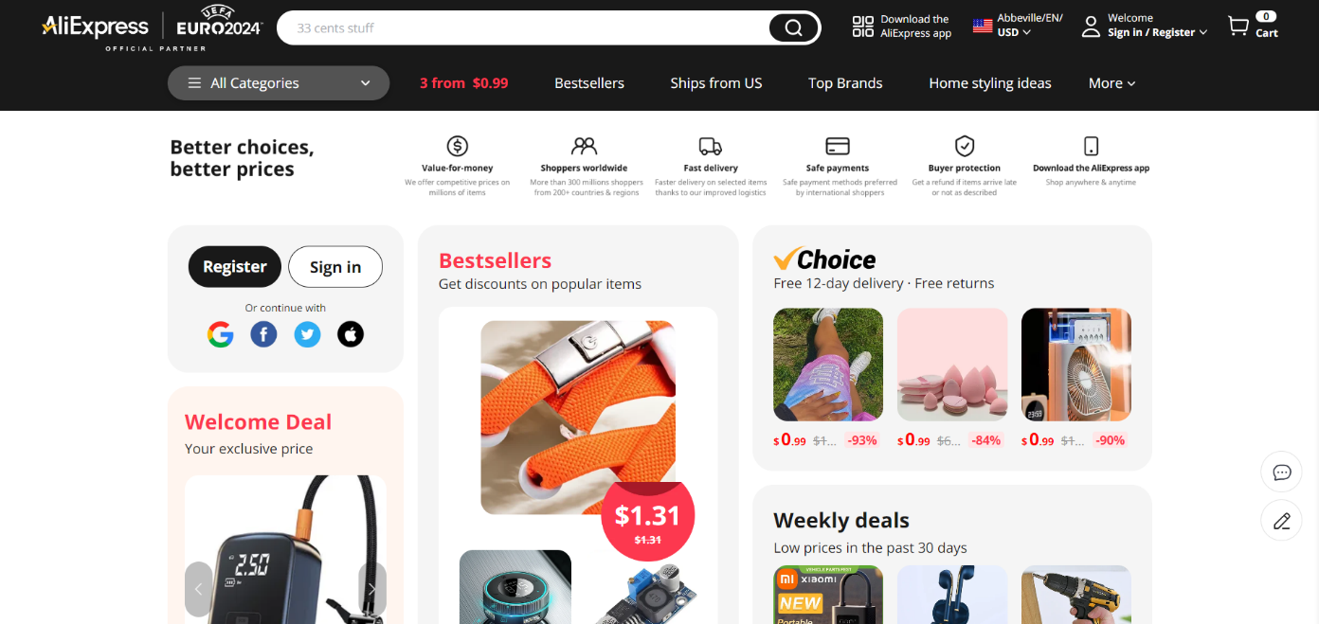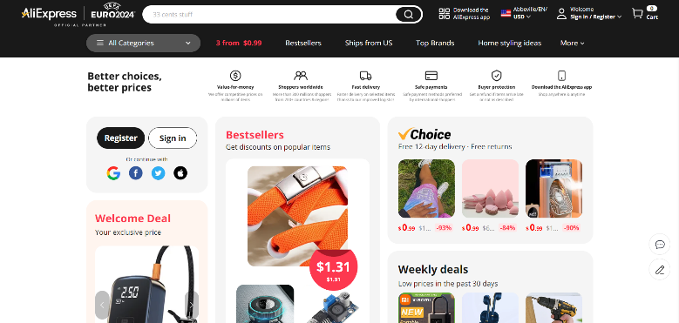

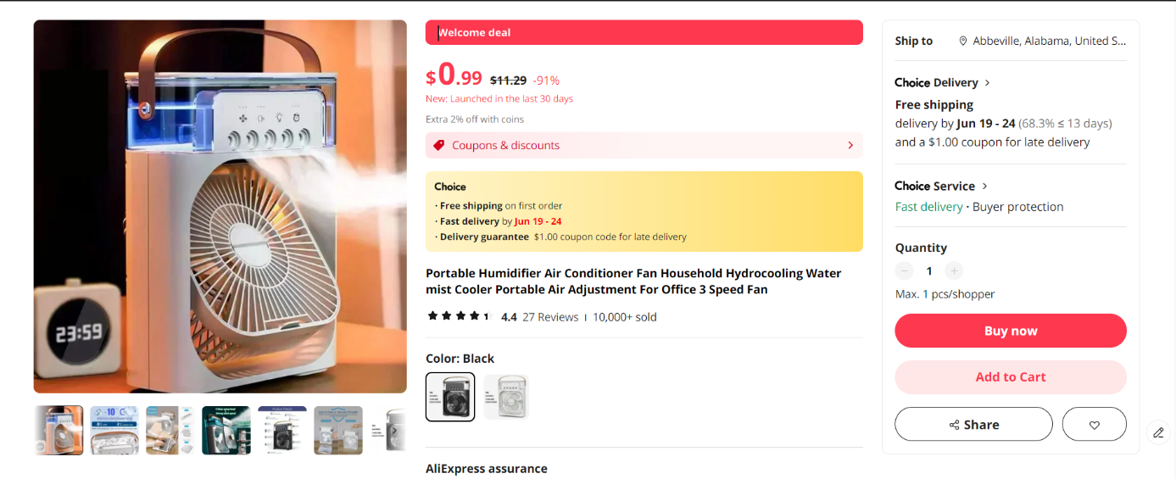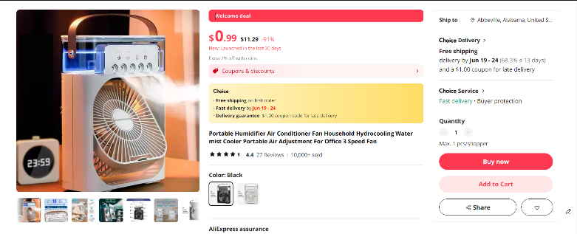

Above you can see other examples where the affordance principle is applied with similar visual and perceptual cues on Aliexpress website.

* **Use in the Navigation Section**

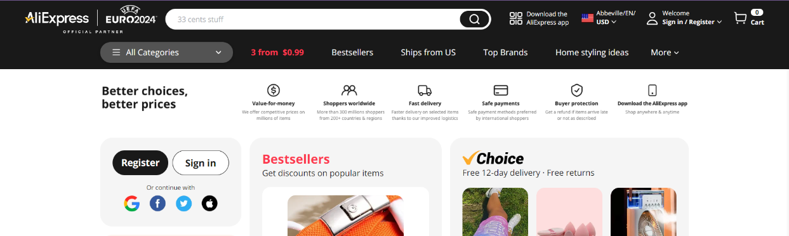

6.3 example

In 6.3 example, the background color of the navigation is different from the background color of the rest of the website. That's a visual cue when applying the affordance principle. In this way, the user intuitively understands that the area with a different colored background is navigation. Having the navigation at the top of the website is a perceptual cue. In this way, the user intuitively understands this section is navigation section.

* **Use in Form Elements**

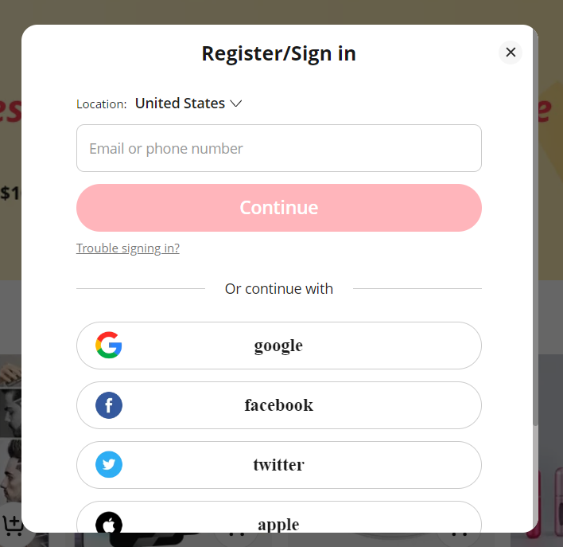****

6.4 example

In 6.4 example, placeholder text “Email or phone number” is used as perceptual cue when applying the affordance principle. In this way, the user intuitively understands that the function of this element.

* **Use in Carousels Element**



6.5 example

In 6.5 example, the carousel element has a left and right arrow icons. That's a visual cue when applying the affordance principle. In this way, the user intuitively understands that this section is a carousel.

* **Use in Card Element**

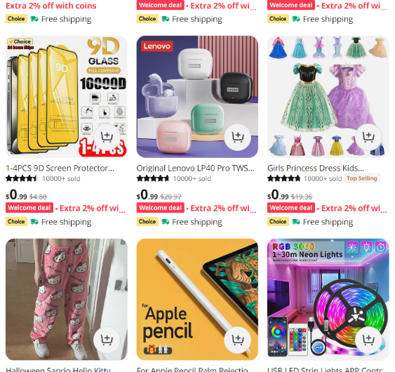 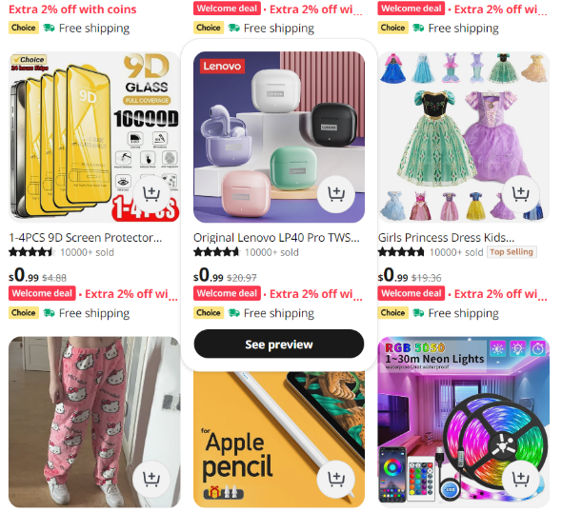

6.6 example

In 6.5 example, the card element is a clickable card. When hovering over this card, it rises slightly and covers a little of the card below it. I think it's not enough because there is no shading. Nevertheless, this is a visual cue when applying the affordance principle. In this way, the user intuitively understands that this card is a clickable card and has the function of "redirecting to the relevant page" when clicked.

**7.** **Mapping**

Mapping is the principle of layout and organization that allows users to easily understand the relationship between the actions they perform on a system's interface and the results of those actions. The aim of this principle is to increase ease of use and efficiency. Let's take a look at how this principle is applied on Aliexpress.

* **Use in Categories**

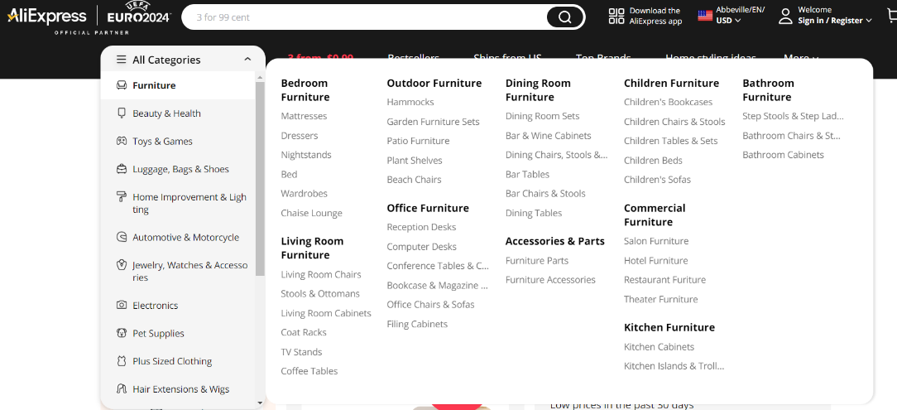

7.1.1 example

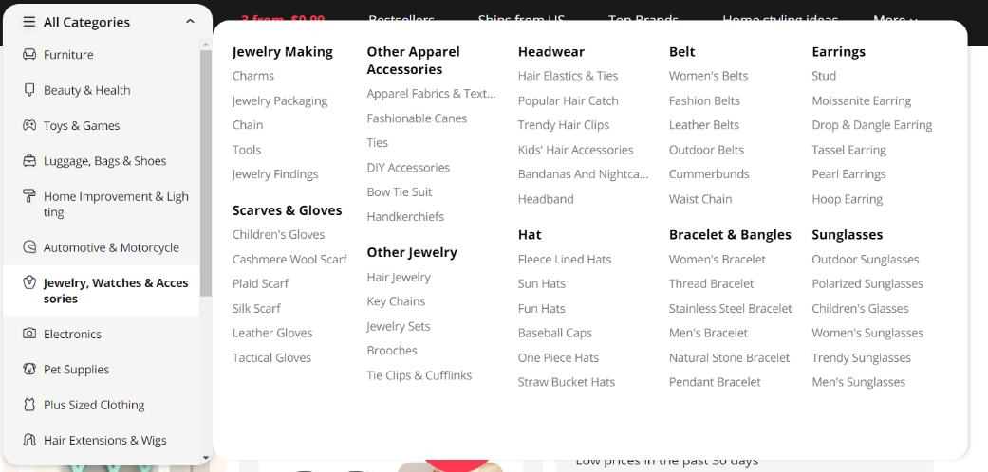

7.1.2 example

In 7.1.1 example and 7.1.2 example , categories are grouped and organized in a logical way according to product types. In the main menu, main categories such as "Furniture", "Beauty & Health", "Electronics", "Jewerly, Watches & Acceressories" are organized with subcategories (e.g. "Bedroom Furniture", "Outdoor Furniture"). When the user hovers over each category, they can easily access the subcategories via side menus. This organization allows the user to easily understand which products can be found in which category. This is a good example of the use of the mapping principle.

* **Use on the Product Page**

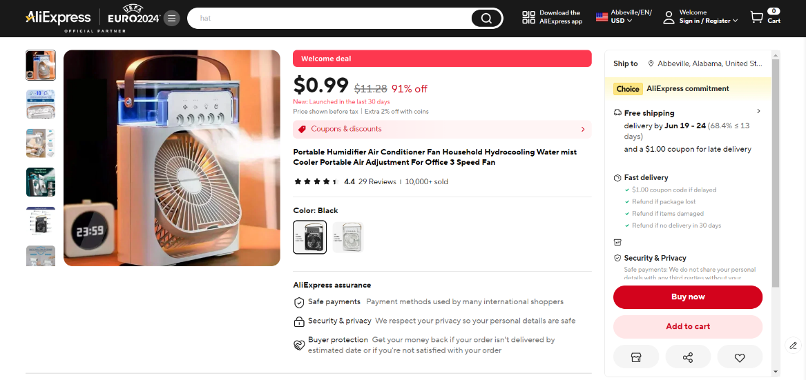

7.2 example

In 7.2 example , the product page has product images on the left, product information (name, price, description) on the right, and the "Add to Cart" button in a prominent and accessible place. Product images are large and clear, product information is readable and organized. When a user opens a product page, the first thing they see is a large product image, with the product name, price and description on the right. This layout helps the user easily find all the information they need. This is a good example of the use of the mapping principle.

* **Use in Cart and Checkout Page**

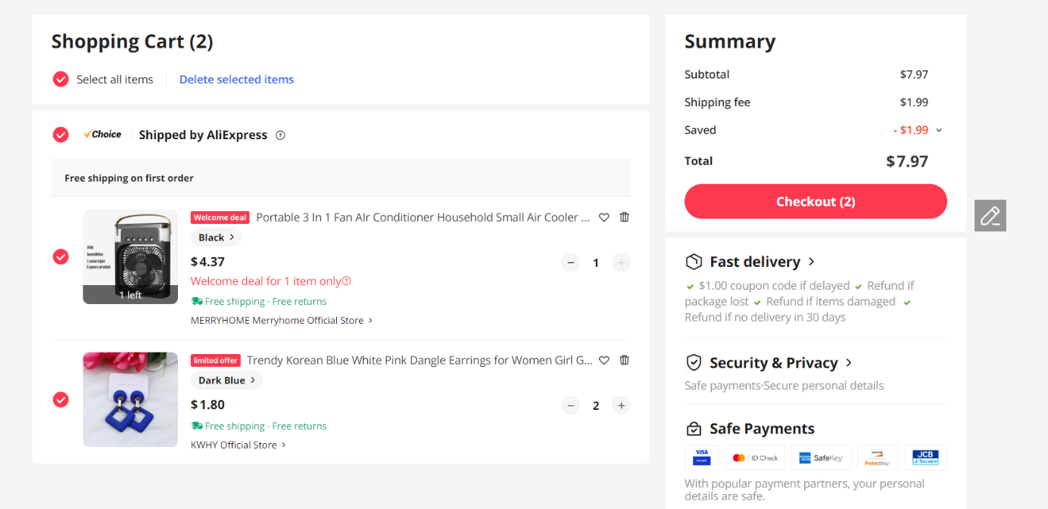

7.3 example

In 7.3 example, on the shopping cart page, the products are listed, the name, price and quantity of each product are clearly shown. The checkout button is prominently placed on the right side of the page. The user can easily see the information they need for the checkout process and complete the checkout. This is a good example of the use of the mapping principle.

* 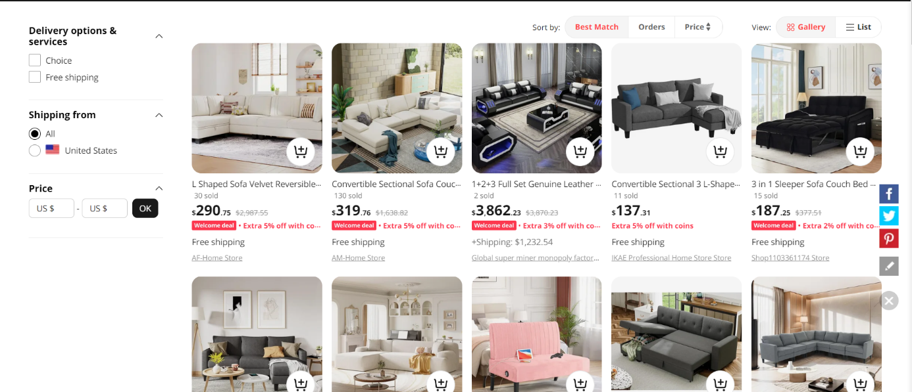**Use in Filters and Sorting Options**

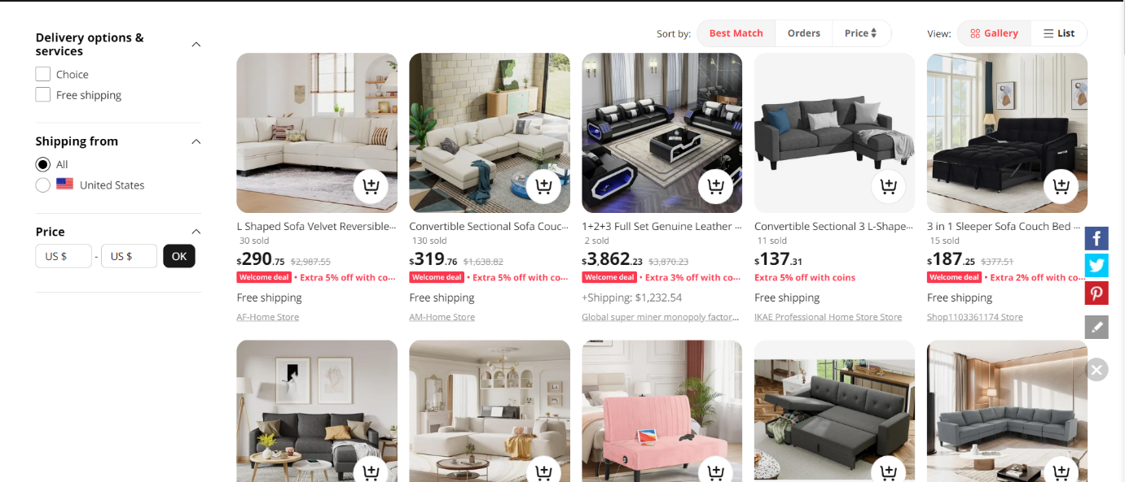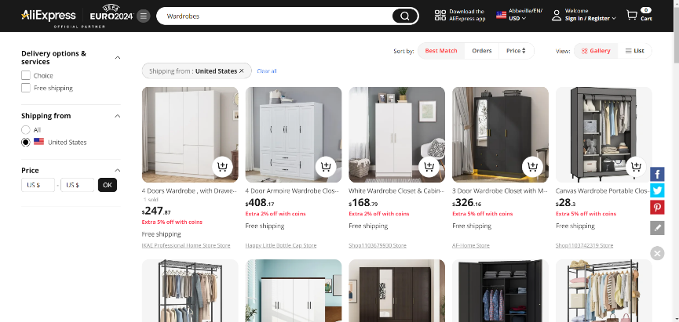

7.4 example

In the product listing page in the example above, filters are on the left side and sorting options are on the top. Filtering options (price, shipping from, delivery options & services) are organized in a clear and easy to use way. When the user selects a filter, it is immediately activated and the results are automatically updated. Also, the selected filters are shown at the top, so the user can easily see which filters they have applied. Although the variety of filtering options is not sufficient, it is an example of mapping because of the successful layout.

Discussion and Conclusion

As expected, AliExpress's website fulfills most of the requirements of the Norman 7 principles. Nothing else could be expected from this brand, which has an important place in its market. After all, success is not a coincidence. However, this does not mean that AliExpress' website complies with all seven of the seven principles one hundred percent. There is room for improvement, especially in the implementation of the principles of "Feedback", "Affordance" and "Mapping". To give an example of these areas for improvement, the "Affordance" principle is used correctly throughout the site, but it has problems in the "Card" element. With the right shadows to be added to the image of the Card element, this deficiency can be identified and made more compatible with the "Affordance" principle. For better implementation of the "Mapping" principle, filtering options can be increased. For the "feedback" principle, user behavior can be better examined and more compatible and new feedback systems can be added to the site. If we leave these areas for improvement behind, as a team, we found the website very successful and worthy of the AliExpress brand. In order to better understand our thoughts on the site as an individual user, you can see the system usability scale tests below, which include the individual opinions of each of us.

Hatice Çankaya's system usability scale test: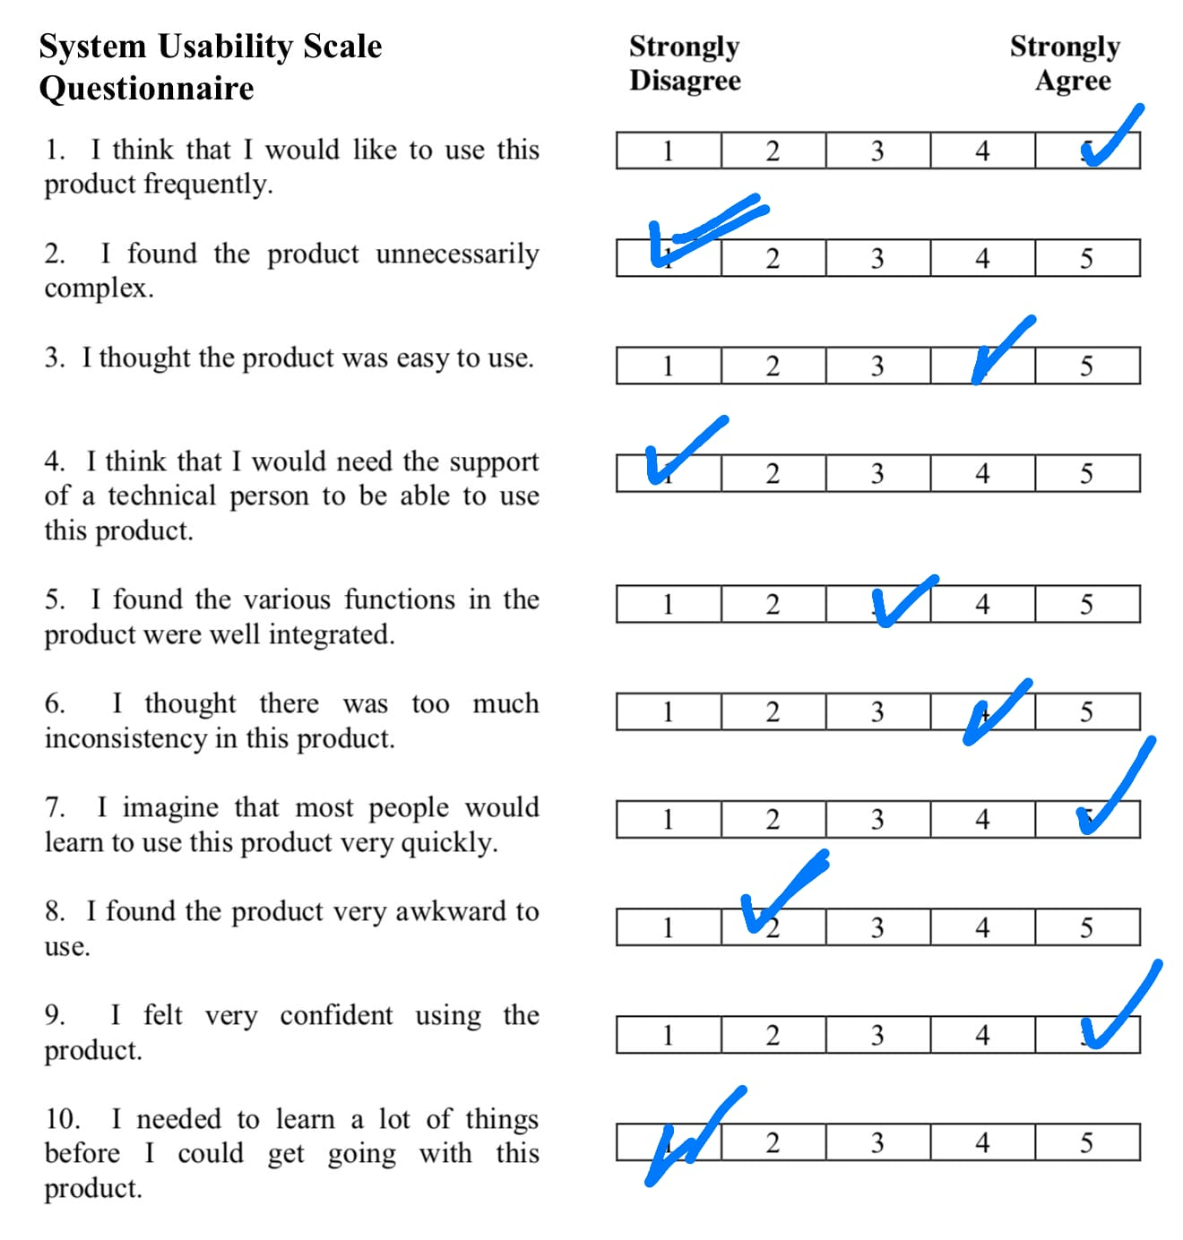

Abdulbaki Akgün's system usability scale test: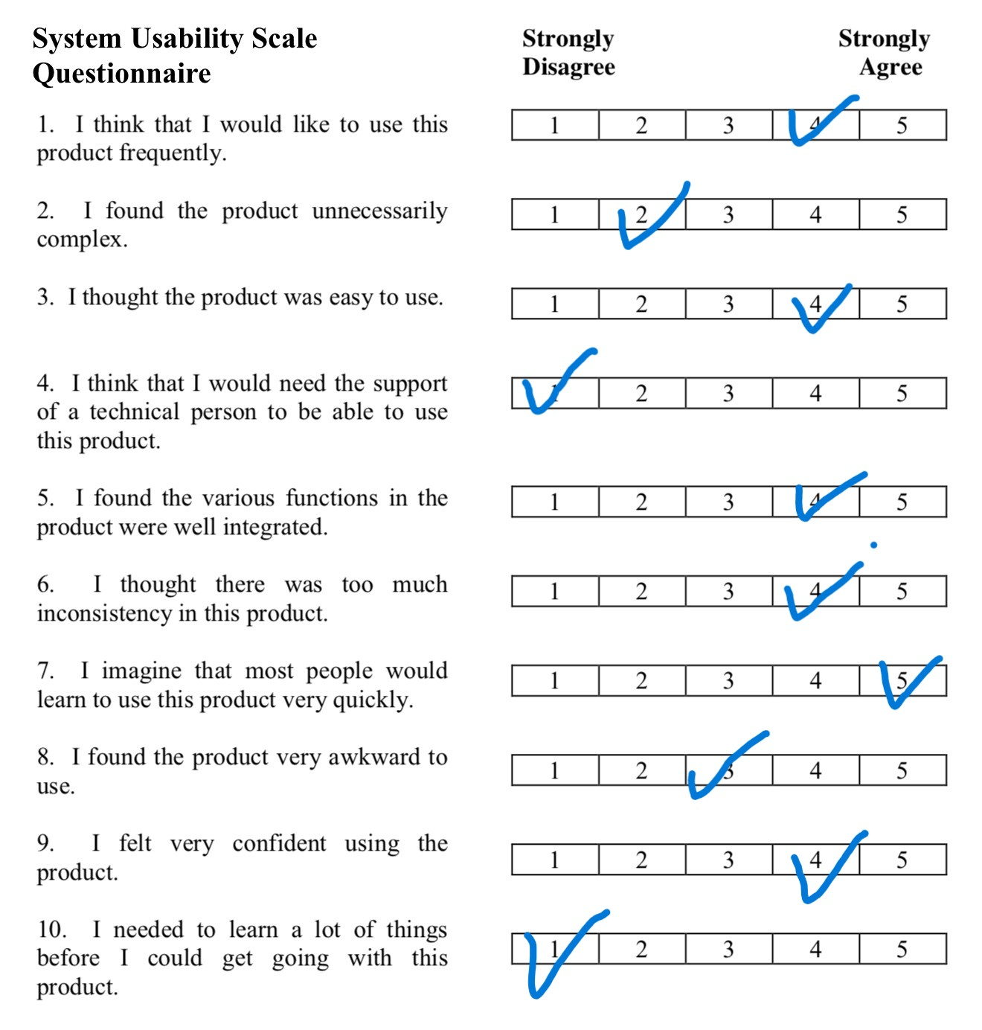

Neslihan Çatak's system usability scale test: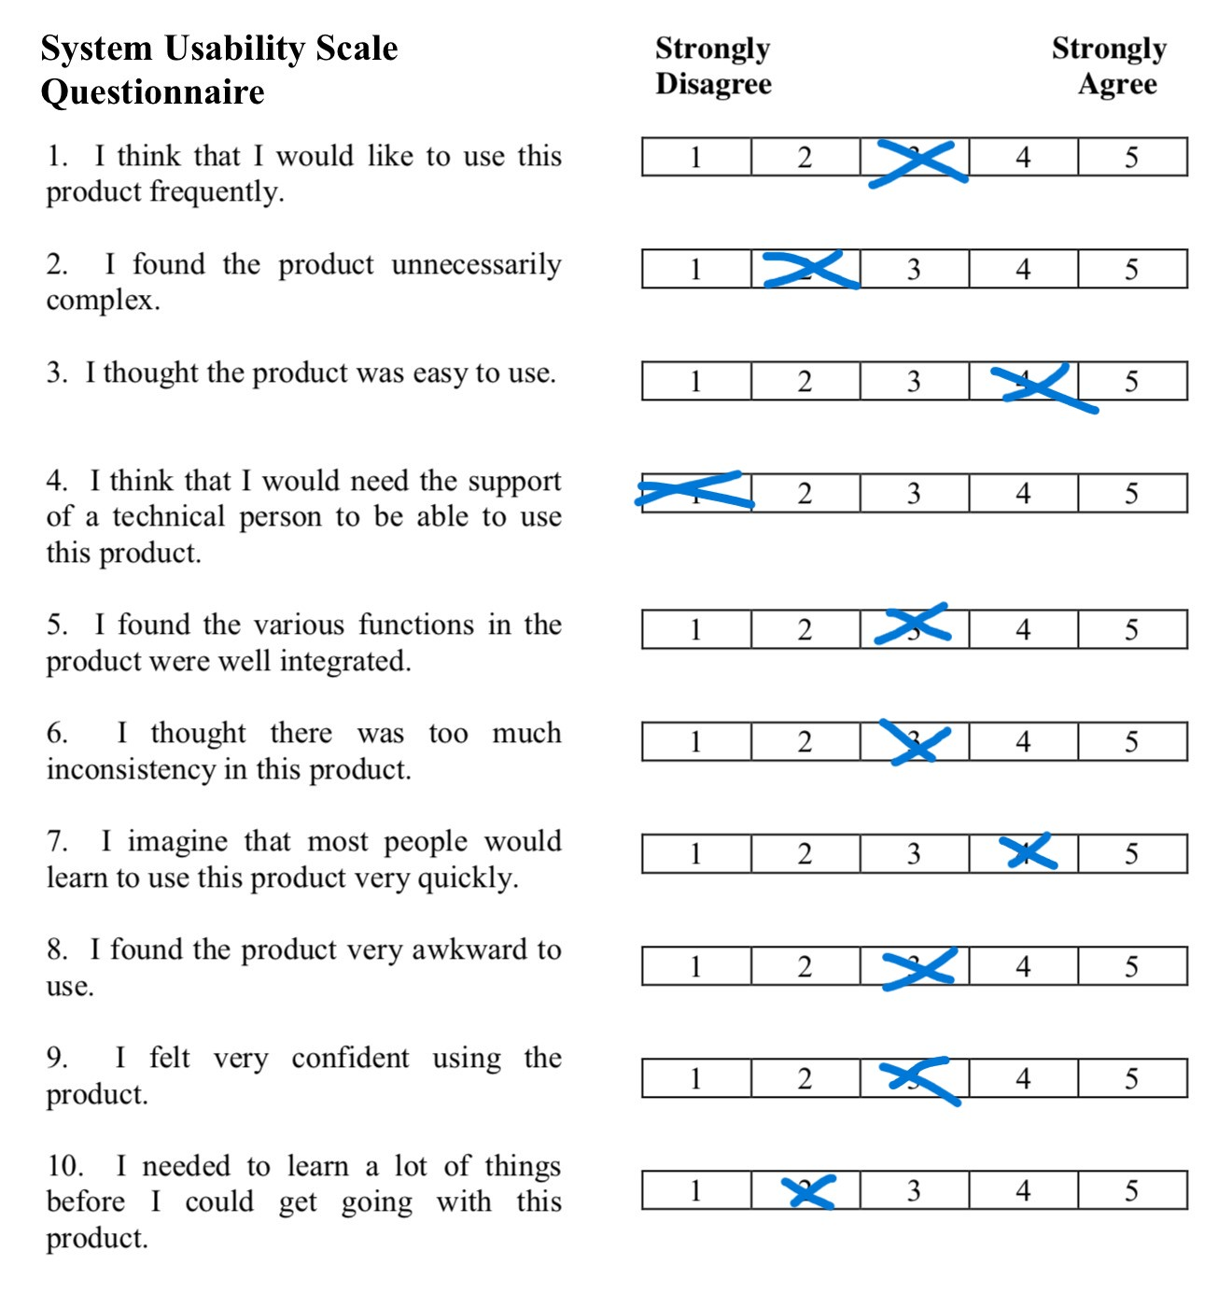

Our system usability scale test average:

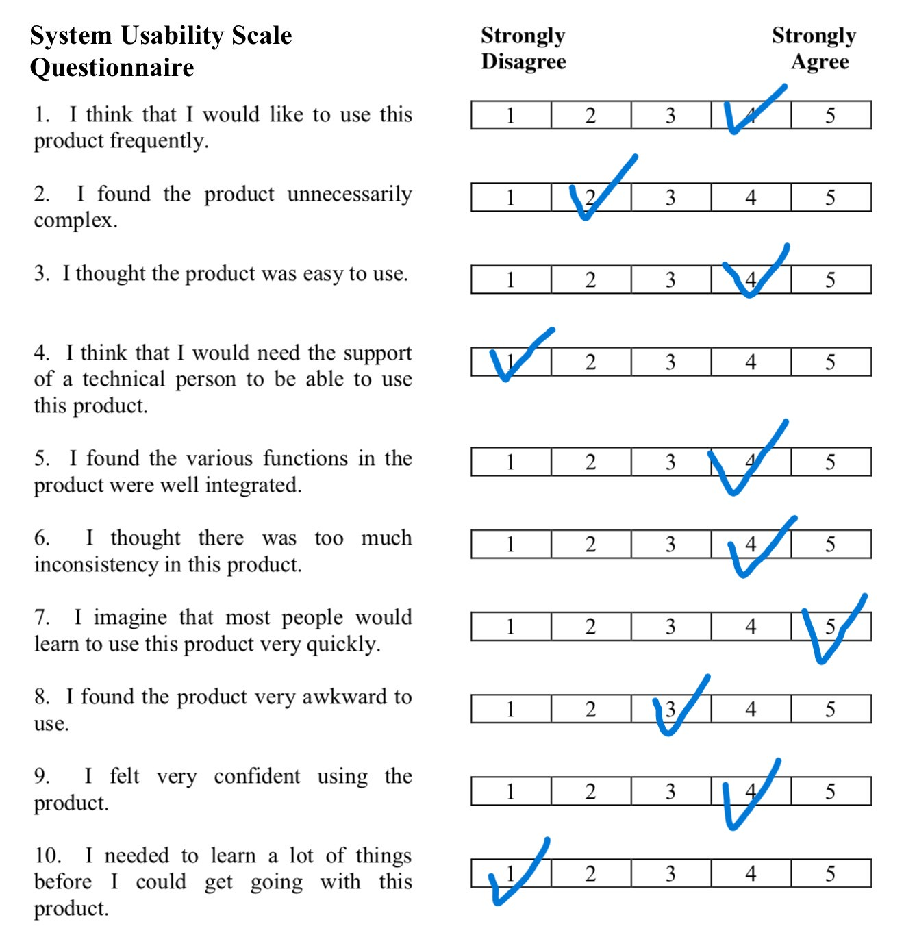

**References**

* Norman, D. A. (2013). **The Design of Everyday Things**. Revised and Expanded Edition. Basic Books.
* Lidwell, W., Holden, K., & Butler, J. (2010). **Universal Principles of Design**. Rockport Publishers.
* Interaction Design Foundation. (n.d.). **The 7 Principles of Universal Design**. Retrieved from <https://www.interaction-design.org/literature/article/the-7-principles-of-universal-design>
* Shneiderman, B. (1998). *Designing the User Interface: Strategies for Effective Human-Computer Interaction*. Addison-Wesley.
* Nielsen, J. (1995). *Usability Engineering*. Morgan Kaufmann.
* Card, S. K., Moran, T. P., & Newell, A. (1983). *The Psychology of Human-Computer Interaction*. Lawrence Erlbaum Associates

**Acknowledgments**

* Neslihan ÇATAK
* Hatice ÇANKAYA
* Baki AKGÜN